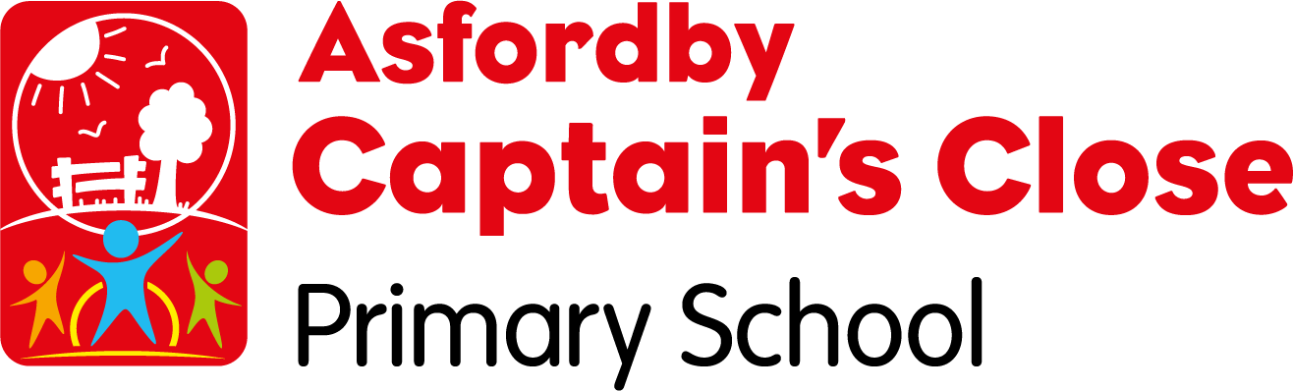
Sports Grant Planned Budget Spending 2023/ 2024 /2016
Carried over from 2022-2023: £2,878.
Total allocated for 2023-24: £17,408
Total allocation for 2023-24: £20,398

Key indicator 1: Increased confidence, knowledge and skills of all staff in teaching PE and sport.

Action | Projected Cost | Rationale | Further details | EYFS | Y1 | Y2 | Y3 | Y4 | Y5 | Y6
1.  Membership with the Melton and Belvoir Sports Package | £1900 Melton and Belvoir  £1000  Course and cover costs | To ensure that the Sports Coach is teaching high quality PE to all pupils in the full age range.  To ensure that teaching staff’s knowledge and skills remain proficient.  Sports Coach and PE lead to meet at least half termly. | Provides necessary opportunities:  - The Melton and Belvoir SSP provides CPD opportunities for PE and teaching staff in the form of planned training courses/network meetings/preparing for sport competitions etc allowing confidence, knowledge and skills of staff involved to be increased.  Eg: Big Moves Programme to support early intervention of physical literacy.  - Club link and professional coaching opportunities - providing CPD for staff when professionals come in and deliver taster sessions or blocks of work.  - Inclusive CPD opportunities and links to expert professionals.  All above provide opportunities for teaching and non-teaching staff (supporting 1:1) to increase their confidence, knowledge and skills.
2.  Skills audit completed by PE team and all non-specialist staff supporting PE - appropriate training arranged. |  | Provide opportunities for teaching and non-teaching staff (supporting 1:1) to increase their confidence, knowledge and skills by planned CPD opportunities.
3.  PE coach to work alongside sports TAs to develop knowledge and individual needs of staff. |  | To ensure that specific activities/skills are shared and developed within the team to keep children’s individual needs are met and interest, enjoyment levels remain high.
4. Continue to use Get Set 4PE online assessment and tracking tools - Key skills review for EYFS, KS1, KS2. | £550 | To ensure that key skills and correct progression are being taught consistently throughout the school whilst supporting to increase the confidence and knowledge of the teachers and support staff. | The scheme also comes with an assessment and tracking tool which will allow progression to be tracked and monitored carefully.
Total= £3450
Evaluation:
Action 1
As part of the Melton and Belvoir membership, our Sports Coach and PE lead have attended termly meetings – providing important CPD opportunities alongside other partnership schools – enabling time to discuss good practice and develop ideas for improvements. Sports coach and PE lead have followed this up with weekly meetings, allowing PE lead to mentor and support new PE coach in her new role.
Action 2
We have also benefitted from personalised CPD – linked to staff audit. Our sports coach benefitted from dance and gymnastics CPD from training courses and local clubs coming in and working with our children during PE lessons and after school clubs – benefitting our sports coach, send support staff and children. This resulted in the sports coach having greater confidence when teaching the gymnastics and dance curriculum and preparing teams for dance and gymnastics competitions, as well as increasing her knowledge about inclusivity. Big Moves training was provided for a member of the EYFS team who went on to successfully deliver the programme for EYFS and moved on to deliver it to those that needed it on year 1, which in turn resulted in improved physical development but also impacted on wider school life by children gaining better listening skills and concentration, learning success and appropriate behaviour by most that took part in the programme. Other local clubs have come into school to work with targeted children and staff. These include the following sports: tennis, yoga, orienteering, fencing, football, cricket, basketball and fitness; providing useful CPD and useful upskilling of the children’s skills for competition preparation.
Action 3
Our PE coach utilised her CPD and coaching experience to pass on her knowledge to 1:1 SEND support staff to enable them to support their 1:1 children better during PE lessons, play and lunch times and after school clubs. This has resulted in SEND children feeling more confident to take part in competitions due to them being given more opportunities to take part fully in lessons and clubs.
Action 4
We have continued to use GetSet4PE Scheme, online assessment and tracking tools across EYFS, KS1 and KS2. This has supported the sports coach to ensure that key skills and correct progression were taught consistently throughout the school whilst supporting to increase the confidence and knowledge support staff. This scheme also provides a useful CPD information section.

Key indicator 2: Increase engagement of all pupils in regular physical activity and sport - Chief Medical Officers guidelines recommend that primary school pupils undertake at least 30 minutes of physical activity a day in school

Action | Projected Cost | Rationale | Further details | EYFS | Y1 | Y2 | Y3 | Y4 | Y5 | Y6
1.  Broad range of extra-curricular clubs offered during lunch and after school – changed half termly to allow more variety. | Sports Coach: £7448 | By providing a range of supervised and structured activities at lunchtime children will be given the opportunity to participate in a variety of different activities enabling those that can’t make after school clubs. Increasing activity levels at the same time as supporting a reduction in behavioural incidents.  Specific lunch clubs will prepare children for upcoming competitions. | Sports ambassadors and sports leaders engaged and effectively deployed. Selected children (Sports Ambassadors and play leaders) are given training and regular support to take up leadership roles. Children are trained in how to effectively arrange and deliver interesting an engaging break/lunch time activity. Pupils are used in the promotion and implementation of ‘active lunchtimes.’
2.  Provide all pupils with opportunities to access free sporting and physical activities, (including interventions during school time, active lunchtimes and extra-curricular clubs), in addition to their PE lessons. | Sports Coach: As above | Engage children that are less engaged due to financial difficulties or opportunities.  Pupils identified as least active/low confidence/SEND are offered an active break/lunch/after school club. | Club engagement will be tracked and monitored allowing specific low engaged groups to be targeted to get involved in specific activities specifically to get children more engaged in sporting activities Eg Change4Life/Competitive engagement/Work it Weekly – allowing children to have a go at a variety of different activities/sports.  Big Moves Fundamental Movement intervention offered to EYFS (KS1 pupils that need it) to provide early support.
3.  External club links created. |  | To provide opportunities for children to continue developing their interests and skills beyond the school day | Engagement with Melton and Belvoir SSP – allowing contacts to be made with local clubs.
4.  Purchase of play and PE equipment for KS1 and KS2. | £8000 | To ensure that the children can play a variety of games at play and lunch - additional equipment will be required. Developing gross and fine motor skills and increasing physical activity levels. | This will be refreshed half termly to keep children’s interest up and allowing a variety of different sports and activities to be offered.
5.  Daily Travel Tracker initiative | Part of the Melton and Belvoir Membership | Daily tracking of how families are travelling to school using the Travel Tracker Program to encourage children to walk, scooter, cycle etc. to school – highlighting the importance to have active lifestyles and make healthy choices on a daily basis.  Promoting links with the community. | This is part of the school’s daily routine.  Take part in Active Travel Month, Walk to school week etc.
6.  Early cycling (balance Bike Training) for EYFS children and Cycling Proficiency for Yr 6 children. | Part of the Melton and Belvoir Membership  Leicestershire County Council | To inspire early enjoyment and skill for cycling. Developing coordination and balance.  Increasing confidence for the children to cycle outside of school to increase activity levels. | Outside provider working with the children and staff and support staff’s CPD.
7.  Additional Swimming Lessons to ensure Y6/Y5 reach National requirements. | £500 | To ensure that all pupils reach the minimum requirements for swimming:  - swim competently, confidently and proficiently over a distance of at least 25 metres  - use a range of strokes effectively  - perform safe self-rescue in different water-based situations | Supporting the vulnerable children fund the provision provide.
Total= £15,948
Evaluation:
This Indicator was a big focus this year.
Action 1
Sports leaders were given training at the start of the year and provided support for clubs and competitions throughout the year which has supported increased engagement and participation in competitions. One example of this; sports leaders lead KS1 Mini Olympics competition during the summer term – this gave every KS1 child a competitive experience in a familiar environment, so they were able to really enjoy the experience.
Action 2
Using the GetSet4PE trackers, we were able to identify children who were less engaged in physical activity or not achieving ARE standards within the curriculum and provide targeted interventions or invite them to specific after school activities, such as Big Moves Programme for EYFS and Year 1 pupils and morning interventions and Work-it-weekly Club for KS2 children. This allowed children to experience a wide variety of different activities to have a go at to see if they enjoyed taking part. This also helped support attendance too. As a result, engagement levels improved. This resulted in 82.63% of our children attending at least one club compared to 70.41% last year.
Action 3
We have had a wide variety of local clubs visit our school to work with our children this year. This has resulted in several of our pupils continuing to develop their skills outside the school environment and joining local clubs. These include; our local cricket, tennis, netball, football and gymnastics clubs.
Action 4
A large amount of money has been spent on purchasing new equipment for play and PE curriculum. This was to ensure that the children increase their activity level by having a variety of games at play and lunch, at the same time as having enough quality and varied equipment to use during PE sessions. This was needed because we had noticed that there were significant weaknesses with fundamental skills in some year groups. Developing gross and fine motor skills and increasing physical activity levels was a key focus this year, so we wanted to make sure that we had the resources required.
Action 5
Children have participated in the WOW Daily Travel Tracker initiative. This has encouraged pupils and their families to travel to school actively. Children have enjoyed gaining badges as a reward for travelling actively whilst also contributing to their minimum daily 30 minutes of physical activity. With 94% of recorded trips being active compared to 91% last year.
Action 6
Early cycling (balance Bike Training) for EYFS children and Cycling Proficiency for Yr 6 children took place. This was used as an aid to encourage increased activity and help to promote their minimum daily 30 minutes of physical activity by having more confidence and enjoyment to want to go for bike rides safely.
Action 7
Additional Swimming Lessons were put in place to ensure Y6 had the best opportunity to reach National requirements during the summer term.
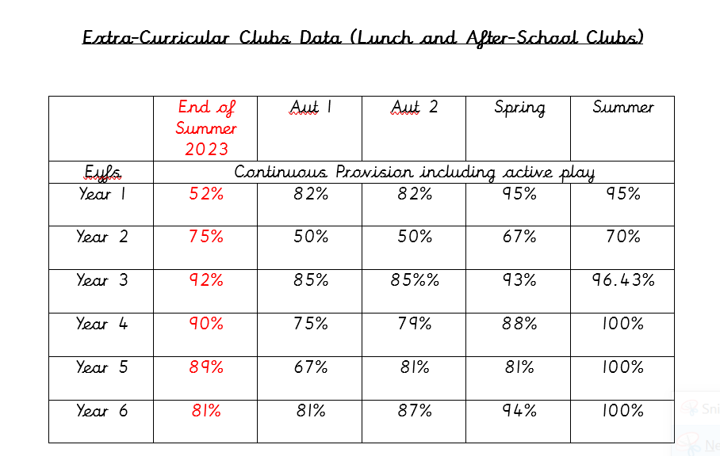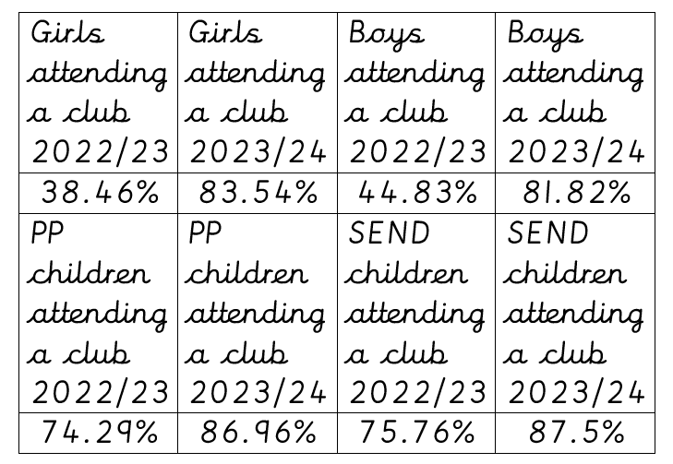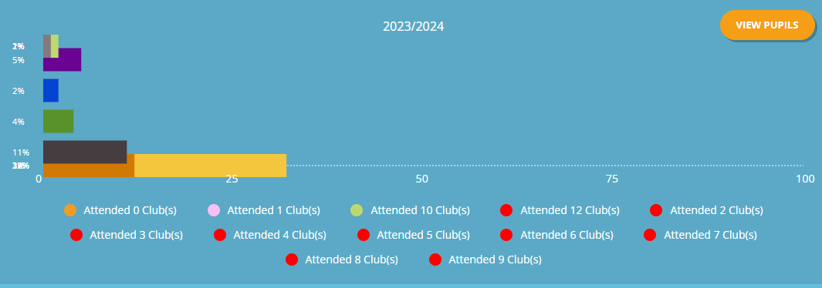
Some children took part in multiple clubs – with some children taking part in 10 clubs.
Key indicator 3: The profile of PE and sport is raised across the school as a tool for whole school improvement.

Action | Projected Cost | Rationale | Further details | EYFS | Y1 | Y2 | Y3 | Y4 | Y5 | Y6
1.  Sports Crew Training |  | Develop the leadership skills of children to allow them to support and encourage others to lead a more active and healthier lifestyle and promote and deliver mini clubs to make lunch times more active. | Sports Crew Training – lead by John Heathcoat.  Sports Coach to support Sports Leader programme.  Supporting virtual competitions, intra class competitions and clubs such as, multi-sports clubs etc.  PE Coach to work with Sports Leaders to promote PE and Sport via displays, social Media – raising awareness of what we do in school and celebrate our successes.
2.  Sports Coach to work towards the criteria for School Games Gold award – more school competitions in wider sports. | £500 – cover costs | To acknowledge the hard work and dedication of the staff and children in the school.  To help ensure that the profile of PE is raised to keep the importance of PE and school sports high in the school.  Making links with local clubs to ensure children and families are aware of where they can go if they want to get more involved in a specific sport – increasing links with local clubs and highlighting sporting pathways. | Social Media – promoting what we are doing in school, what is on offer after school and in the local area and celebrating our successes.
3.  Celebrate sporting successes – certificates. |  | Certificates for competitions to be awarded during assemblies. | Sports coach to nominate children/class weekly to be awarded a certificate in the weekly achievement assembly – linked to the spirit of the games criteria – School Games.  Competition certificates to be given out during the weekly achievement assembly.
Total: £500
Evaluation:
PE lead and Sports Coach have worked hard with the rest of the staff in school to work towards the School Games Gold Award and using social media to ensure that the profile of PE continues to raise to keep the importance of PE and school sports high in the school. The summer pupil survey showed that 72% pf KS2 pupils enjoy PE lessons, with 25% unsure and only 4% not enjoying PE lessons. This was closely linked to how confident the children feel during PE sessions, as results showed similar results - 72% of pupils felt confident, 24% unsure and 4% not feeling very confident. This shows that we need to continue to raise the profile of PE and sport by using the sports crew, rewarding successes and working hard to increase activity levels will continue to support to improve children’s confidence within PE lessons and in turn help to increase levels of engagement and enjoyment for it.
Key indicator 4: Broader experience of a range of sports and activities offered to all pupils.

Action | Projected Cost | Rationale | Further details | EYFS | Y1 | Y2 | Y3 | Y4 | Y5 | Y6
1.  Extra Curricular clubs – after school/lunch.  2.  Promoting local club links. | As above | To provide a broader range of activities to all pupils. | Promoting further links with local clubs - Sign posting pupils and their families to local clubs, community groups providing more information of where they can access (or broadening the variety of) extra-curricular activities after school, delivered by the school or other local sport organisations.  Parent and pupil voice surveys to gain information about what families would like to see offered.
3.  Interventions for pupils that have additional/ physical developmental needs | As above | Big Moves – increase the physical literacy of children that require support.  Inclusion activities delivered by specialists – CPD opportunities. | SEND workshops - Lead by Mark Beeby/Clare Marlow  Staff inhouse CPD training to support children throughout the school. |  |  |  | Summer Term
4.  Purchase of new equipment | As above | Equipment to broaden participation in a variety of different sports needed – Archery Equipment/ Boccia set | Carry out sports equipment H&S check and audit stock.  In addition, Parent and pupil voice surveys to gain information about what families would like to see offered.
Total: £0
Evaluation:
On top of delivering a wide range of sports during our PE curriculum, we have offered lunchtime, after school and morning clubs in order for our children have increased exposure to a wider and broader range of activities and sports. Some have been targeted, free clubs (eg; Work-it-weekly club) to encourage the less engaged, vulnerable or pupil premium children to be able to access them.
SEND children are supported 1:1 in PE lessons to allow lessons to be as inclusive as possible. The PE coaches CPD to Support staff has allowed valuable support staff. The Big Moves programme has been used to support EYFS and KS1 children to support the development of their early physical literacy skills, aiding improve physical development as well as improved behaviour. Using the Get Set 4 PE tracking tool; we have been able to identify children who needed further support and have implemented interventions across the key stages appropriate to children’s individual needs, including fine motor, pre-teaching, Big Moves and fundamental skills style activity interventions, thus encouraging those less confident within whole class PE sessions to have a go at a variety of activities in the hope that they build their confidence and enjoyment for physical activity and sport and in turn encourage them to want to try other activities.
The annual safety check took place (repairs carried out) and new sports, play and lunch time equipment purchased alongside other PE equipment in both EYFS, KS1 and KS2 to allow children the opportunity to try a wide range of activities during the curriculum or extra-curricular activities.
Key indicator 5: Increased participation in competitive sport

Action | Projected Cost | Rationale | Further details | EYFS | Y1 | Y2 | Y3 | Y4 | Y5 | Y6
1.  Attend Melton and Belvoir and DSAT Network Meetings - Continue to enter a range of sporting competitions, events and festivals applicable to pupils of all abilities: | Cover costs  As above | To ensure that children of all abilities have access to a range of local competitions and the opportunity to participate in school sports. | Subscription to Melton and Belvoir SSP provides opportunities for high ability, lower ability, SEND inclusive and less active pupils.  Range of Virtual competitions offered by Melton and Belvoir SSP allowing more children to take part in competitive sport.  Intra school competitions and sports tournaments at the end of each half term.
2.  Sporting Travel Costs | £500 | Coach travel for competitions that involve two teams or a whole class. | Arrange transport for disadvantaged children to/from inter-school events.
3.  Children to get involve in half termly virtual competitions and take part in intra class competitions. |  | Allowing a greater number of children to take part without the disruption of having to go to a different venue.
Total: £500

Evaluation:
Sports Lead and Sports Coach attended Melton and Belvoir Network Meetings – these meetings are valuable networking opportunities to discuss with local school how to improve possible opportunities for children to enter a range of sporting competitions, events and festivals applicable to pupils of all abilities along with useful CDP training.
Over the last year we have entered 15 Inter School Competitions and intra school competitions and festival events. 52% of KS2 children across the school took part in inter school sports competition during 2023-24 in at least one competition. This was slightly down on last year but more children did more than one competition. All pupils across the school have participated in at least one intra, virtual or whole key stage and school competitions.
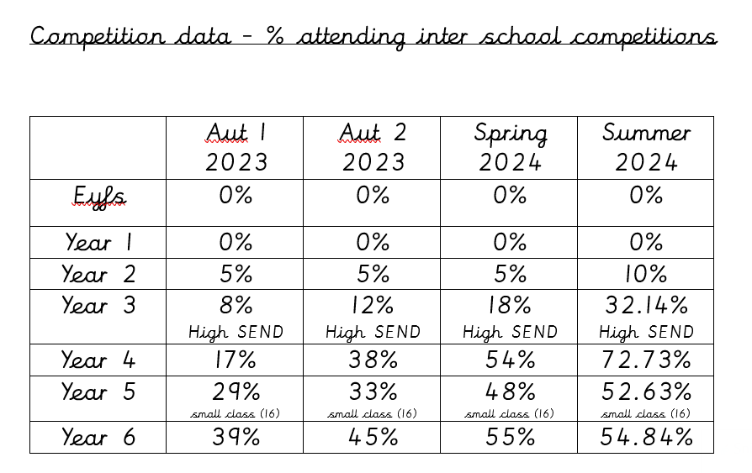

KS2 PP children:
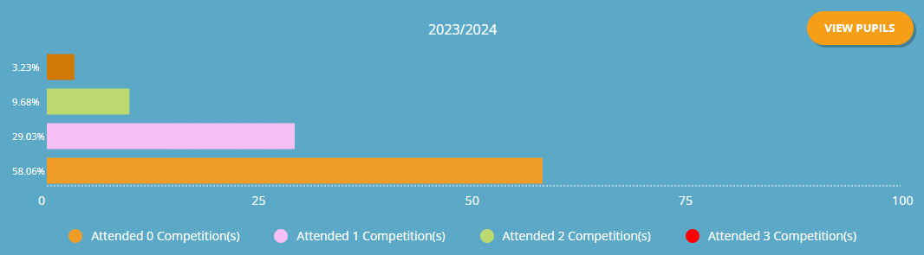

SEND KS2:

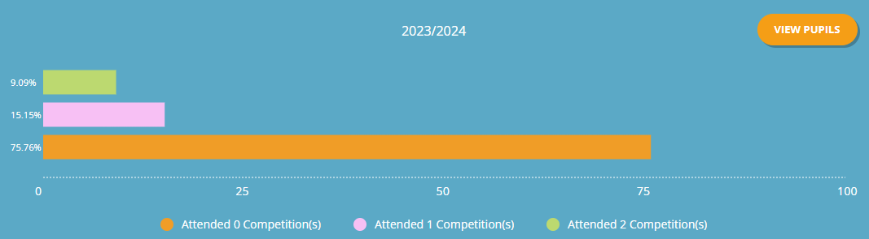

Boys KS2:

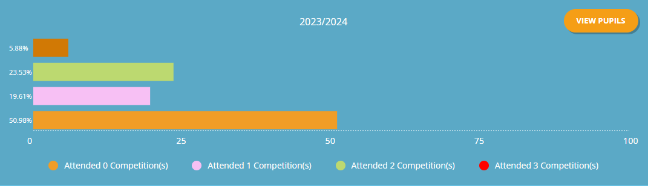

Girls KS2:

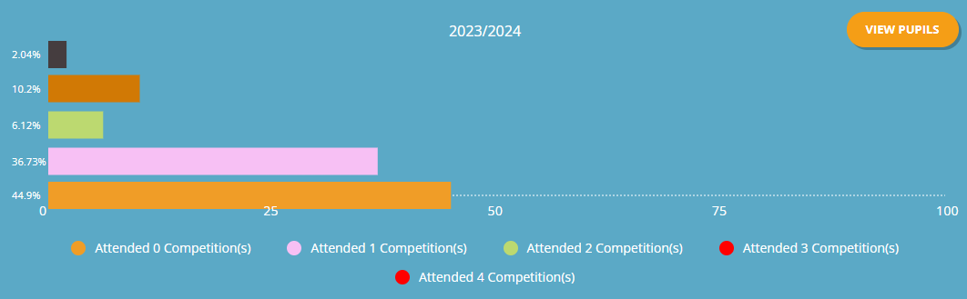

Total spent £20,398

Key Achievements: | Areas for further improvement and baseline evidence of need:
Gaining the ‘School Games’ GOLD Award.  Being nominated for Melton and Belvoir for Contribution to PE and Sport.  A pupil being short listed for Sports Personality Award in the DSAT Awards.  Increasing participation in physical activity by offering a wide variety of clubs in the morning, lunch and after-school encouraging at least 60 minutes of exercise a day to all children (pp, SEND, girls and boys) We have also continued to use Travel Tracker to promote active travel to school. This was a main focus this year.  Attendance to extra-curricular clubs (Morning, lunch and after-school)  Whole school:  2022/23 70.41% 2023/24 82.63%  KS2:  2022/23 97.88% 2023/24 99%  KS1:  2022/23 65.31% 2023/24 82.05%  Successful new appointment of a new sports coach who promotes enjoyment of sport with a clear skill progression approach.  Get Set 4 PE tracking tools used well to track in inactive and less engaged children, resulting in the school being able to offer and target specific individuals/groups to attend extra-curricular clubs.  Children have enjoyed inter-school competitions and have given great feedback.  Children have enjoyed applying their learnt skills in units of work by pairing up with another class to have intra-class competitions.  Improved club links – several children have gone on to join local clubs from visits and competitions that we have been involved in.  24.24% of our SEND children in KS2 actively involved in inter-school competitions. It was great to see one of our pupils who is totally blind competing against her peers unaided in the gymnastics competition. | Continue to develop  PE staff and TA support: Skills Audit – provide needed CPD  Ensure all children have the opportunity to take part in 60 minutes of sport and physical activity per day. Encourage active learning in the curriculum as a whole – using the outdoor environment – especially for those that struggle to learn in a classroom setting and younger children – eg use phonic outdoor paintings to develop the children’s phonic skills. Continue to develop of the outdoor forest school area.  Increase the number of virtual competitions in a variety of different sports to allow more pupils to take part in them.  Vary the inter-school competitions that we participate in to make sure that a wider number of pupils feel they can confidently take part.  Train up new Sports Leaders to help continue promote active play and lunchtime – this will also help with any behaviour issues – introduce challenges (intra competitions) Lead by the sports crew.  Daily boost activities – lead by sports crew. (Increasing opportunities for pupils to achieve 60 minutes of activity each day)  Celebrate sporting contributions weekly – Sporting Star of the week to celebrate behaviour, effort and contributions within PE lessons. Use a trophy per class.  Continued development of the Curriculum and tracker of assessment data (GetSet4PE updates)  Continue to use pupil voice to assist in club offers – offer a wider variety of different activities/sports for clubs which children wouldn’t normally have the chance to take part in during the school day.  Use ‘Big Moves’ programme early to assist in increasing the level of physical literacy skills in EYFS and KS1 where needed in the Autumn term.  Invite inspirational sports people into school to talk to the children to encourage them to become enthusiastic about sport.

Meeting national curriculum requirements for swimming and water safety 2023/24

What percentage of your Year 6 pupils could swim competently, confidently and proficiently over a distance of at least 25 metres when they left your primary school at the end of last academic year? | 81%  22/27
What percentage of your Year 6 pupils could use a range of strokes effectively [for example, front crawl, backstroke and breaststroke] when they left your primary school at the end of last academic year? | 77%  21/27
What percentage of your Year 6 pupils could perform safe self-rescue in different water-based situations when they left your primary school at the end of last academic year? | 77%  21/27
Schools can choose to use the Primary PE and Sport Premium to provide additional provision for swimming, but this must be for activity over and above the national curriculum requirements. Have you used it in this way? | £500 towards additional swimming for year 6.

