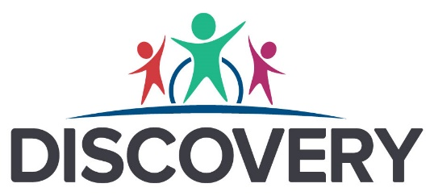
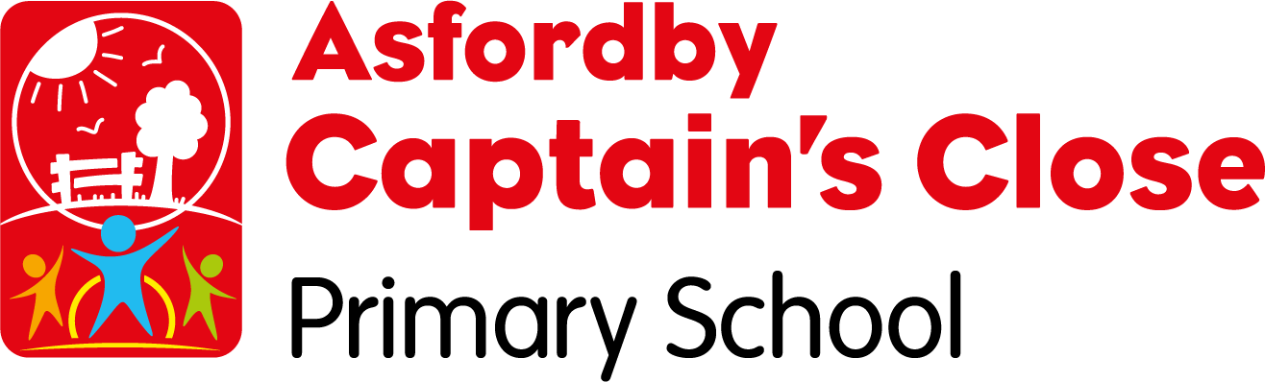

Equality Duty Information Report and Objectives

Version number | 1.0
Approved by | Advisory Board
Approval date | March
Policy/document owner | Andie Bailey
Status | Statutory
Frequency of review | Annual
Next review date | January 2025

Contents
1. Aims 3
2. Legislation and guidance 3
3. [Leicestershire’s/Leicester’s/Rutland’s] diverse population & our school community 3
3. Eliminating discrimination 7
5. Advancing equality of opportunity 8
6. Fostering good relations 9
7. Equality considerations in decision-making 10
8. Our equality objectives for 2021-2025 10
9. Monitoring arrangements 11
10. Links with other policies 11

1. Aims
Captain’s Close Primary School is committed to promoting a positive and inclusive culture in which staff and pupils are valued and supported to fulfil their potential irrespective of their age, disability, race, religion, belief, sex or sexual orientation.
We recognise our obligations under the Equality Act 2010 and aim to meet our obligations under the public sector equality duty by having due regard to the need to:
- Eliminate discrimination and other conduct that is prohibited by the Equality Act 2010.
- Advance equality of opportunity between people who share a protected characteristic and people who do not share it.
- Foster good relations across all characteristics – between people who share a protected characteristic and people who do not share it.

2. Legislation and guidance
This document meets the requirements under the following legislation:
- The Equality Act 2010, which introduced the public sector equality duty and protects people from discrimination
- The Equality Act 2010 (Specific Duties) Regulations 2011, which require schools to publish information to demonstrate how they are complying with the public sector equality duty and to publish equality objectives
This document is also based on Department for Education (DfE) guidance: The Equality Act 2010 and schools.
This document also complies with our funding agreement and Trust articles of association.

3. Leicestershire’s diverse population & our school community
Leicestershire is an ethnically and culturally diverse county, benefiting greatly from close links with Leicester, one of the most culturally diverse cities in the UK.

According to the 2011 Census, most of the county population (91 percent) belong to White ethnic groups, (including White Irish). This equates to almost 600,000 people. The next largest ethnic group in Leicestershire is Asian (6.3 percent), followed by the Mixed or Multiple Ethnic Group (1.7 percent) and Black ethnic groups (0.6 percent); The largest religious group in the county is Christian (60.3 percent), followed by Hindus (2.8 percent), Muslims (1.4 percent) and Sikhs (1.2 percent). Just over a quarter of the population stated they had no religion (27.1 percent) while 6.5 percent did not state a religion.

In 2011, 16.2 percent of the county population considered themselves to have a condition that limited their day-to-day activities, higher than the rates for the East Midlands and England.

According to the 2015 Indices of Deprivation, Leicestershire is not deprived overall; the county is ranked 136th out of 152 upper tier authorities in England for Multiple Deprivation, where 1st is the most deprived.

These are the deprivation rankings for our pupils based on 2023/24 school census information:
In 2023/24 our school was 150th out of 275 primary schools for deprivation with 1st being the most deprived.

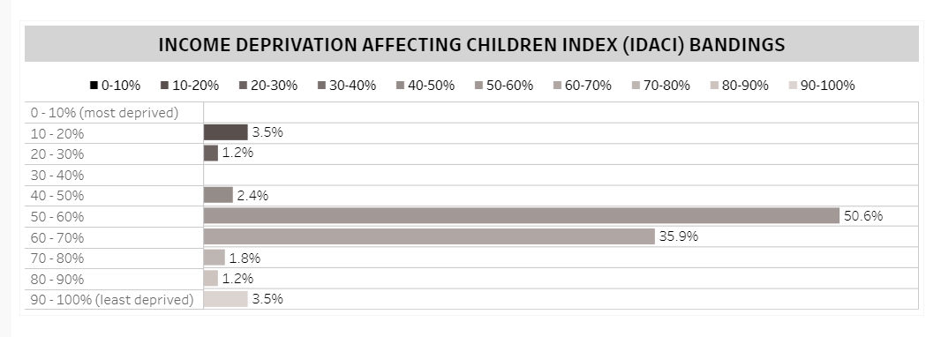

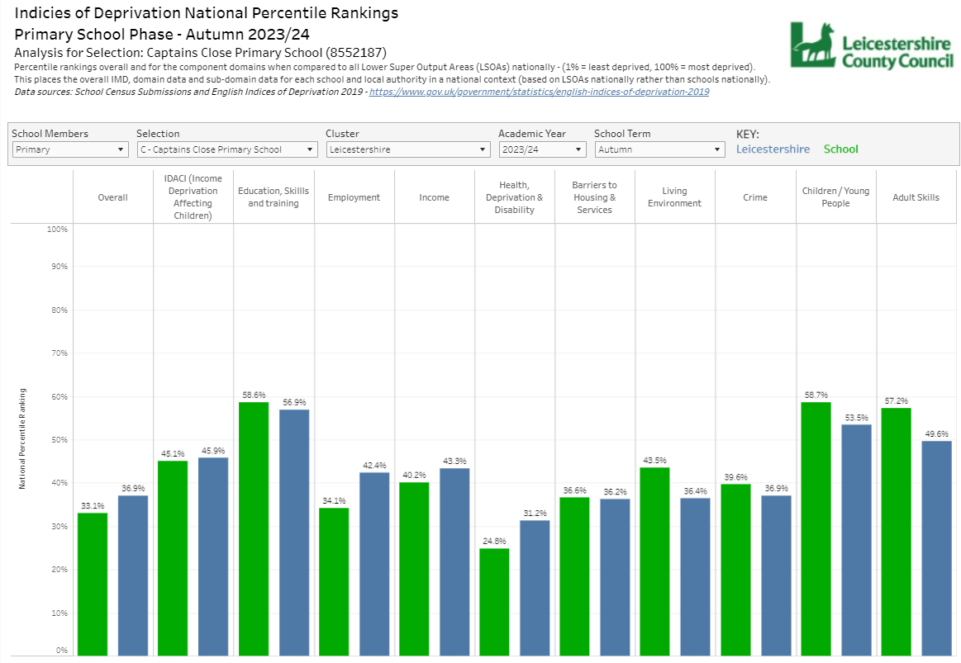

The diverse population of our school
Our school community has its own unique make up:
Information from the school census 2022/2023
Gender profile and demographics:
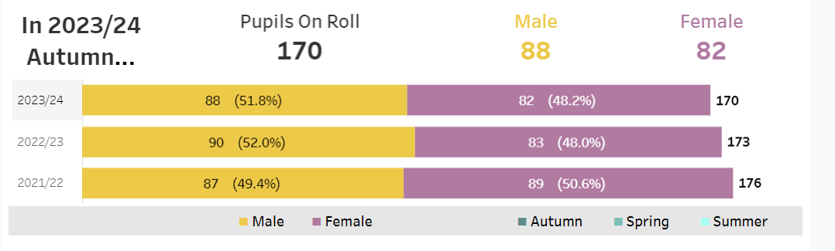
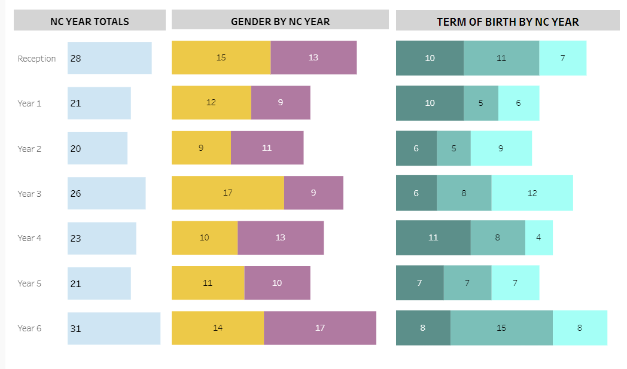

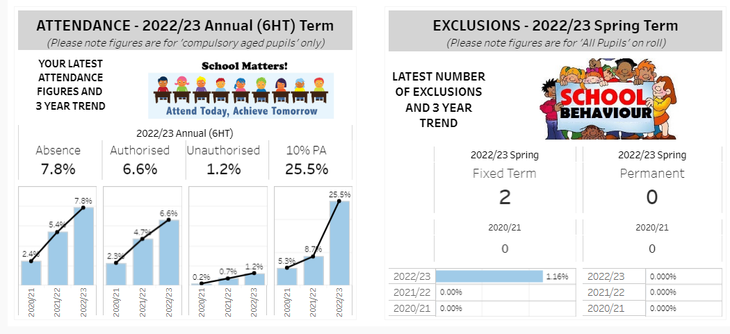
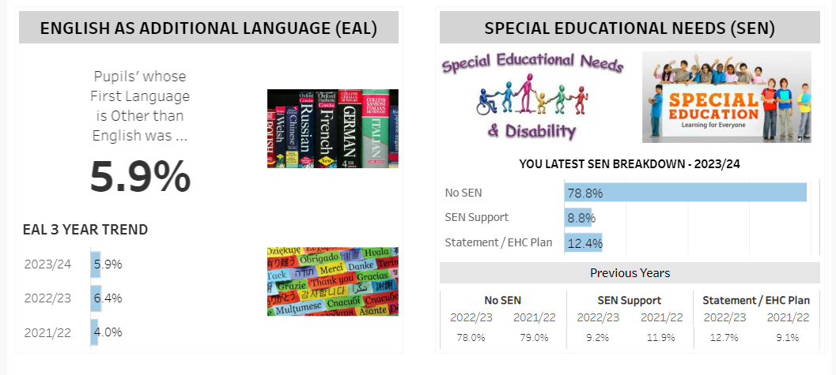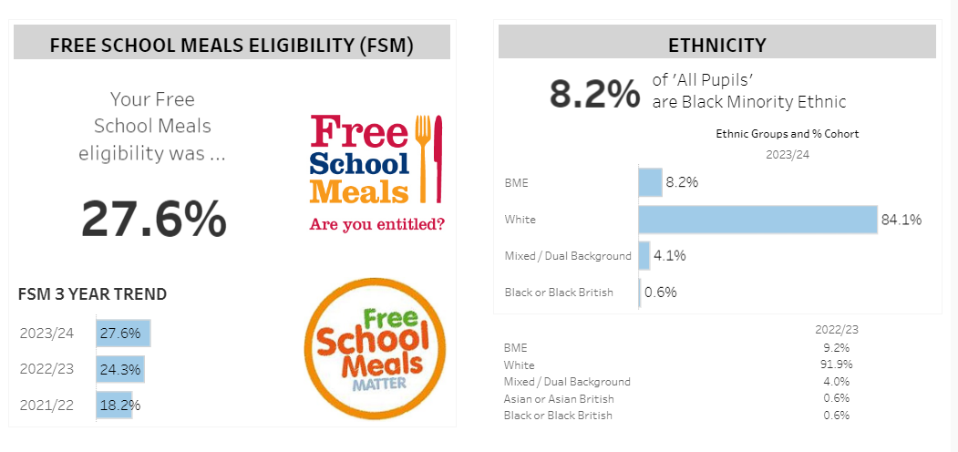
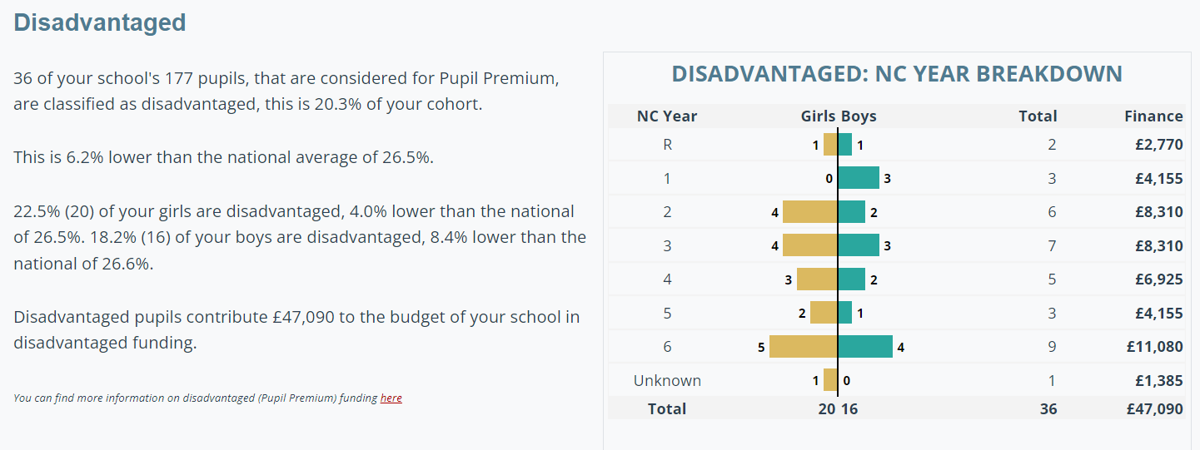

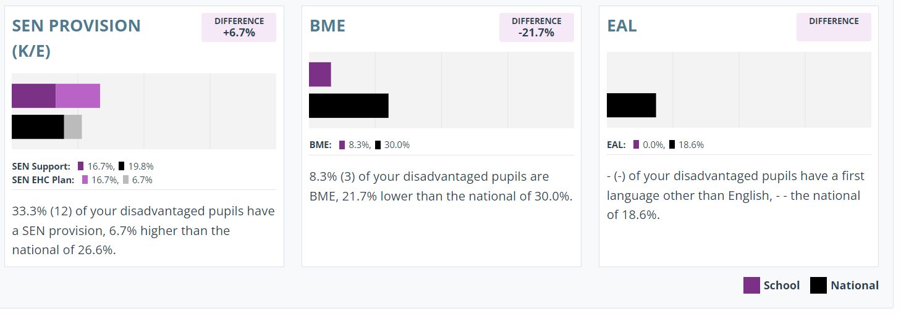

The profile of our workforce and the Advisory Board
- 92.2% of our workforce identify as white British
- 7.8% are from other ethnic backgrounds but low numbers may lead to identification of individual staff
- 89% of our workforce identify as female

3. Eliminating discrimination
The school is aware of its obligations under the Equality Act 2010 and complies with non-discrimination provisions.
- Where relevant, our policies include reference to the importance of avoiding discrimination and other prohibited conduct.
- Our behaviour policy ensures that all children feel safe at school and our anti-bullying policy addresses prejudicial bullying
- We report, respond to and monitor all discriminatory incidents
- We listen to and monitor views and experiences of pupils and adults to evaluate the effectiveness of our policies and procedures.
- New staff receive training on the Equality Act as part of their induction, and all staff receive refresher training at the start of every academic year. Information is on the staff noticeboard and is an agenda item at staff meetings. Discovery polices and procedures are discussed and explained at training and staff are aware of their location on the Teams platform. School practice and curriculum expectations are also refreshed as part of this training.
The designated senior member of staff with overall responsibility for monitoring equality issues is the Executive Headteacher.
The Advisory Board consider the equality implications of data reports and the policies it is responsible for reviewing.
What we did during the last year
- Reviewed the behaviour policy and CPOMS tabs to ensure the language used is inclusive and appropriate and covers all protected categories so that incidents can be recorded, monitored and analysed correctly and any trends can be spotted.
- Reviewed Safeguarding Policy
- Adopted blind recruitment procedures to ensure recruitment practices are not discriminatory
- Reviewed the Anti-Bullying Policy
- Reviewed the Accessibility Plan

5. Advancing equality of opportunity
In fulfilling this aspect of the duty, the school will:
- Publish attainment data each academic year showing how pupils with different characteristics are performing
- Analyse the above data to determine strengths and areas for improvement, implement actions in response and publish this information
- Make evidence available identifying improvements for specific groups (e.g. declines in incidents of homophobic or transphobic bullying)
- Analyse data on participation rates in extra curricula activities for pupils with different characteristics
- Listen to the views of parents/carers, staff and pupils

What we did during the last year
- Initial review of curriculum content regarding inclusion and diversity to ensure children are taught about significant individuals representing all groups with protected characteristics and to ensure all children see them represented in the curriculum we teach. To inspire all children to be ambitious and see the range of opportunities available to them.
- We revised trip planning processes and locations to consider the needs of all pupils including those with disabilities or other additional needs to ensure all children can access trips successfully, ready for 2023-2024.
- School staff have completed a survey regarding from the GEC to analyse their understanding of inclusive practice which will form the basis of staff training and changes to provision moving forward. We want to ensure all staff have a secure understanding of inclusive practice in order to support each other and our school community in ensuring the best outcomes for everyone in education, wellbeing and life chances
- The SENDCO has improved reporting of SEND provision to ensure a consistent approach and timely communication with parents to ensure all children have access to quality learning opportunities that meet their needs and is also available on the playground for discussion with parents.
- Anti-bullying policy has been updated to ensure that it tackles discrimination

6. Fostering good relations
The school aims to foster good relations between those who share a protected characteristic and those who do not share it by:
- Promoting tolerance, friendship and understanding of a range of religions and cultures through different aspects of our curriculum. This includes teaching in RE, citizenship and personal, social, health and economic (PSHE) education, but also activities in other curriculum areas. For example, as part of teaching and learning in English/reading, pupils will be introduced to literature from a range of cultures
- Holding assemblies, virtually during COVID restrictions, dealing with relevant issues. Pupils will be encouraged to take a lead in such assemblies and we will also invite external speakers to contribute
- Working with our local community. This includes inviting leaders of local faith groups to speak at assemblies, virtually during COVID restrictions and organising school trips and activities based around the local community
- Encouraging and implementing initiatives to deal with tensions between different groups of pupils within the school. For example, our school council has representatives from different year groups and is formed of pupils from a range of backgrounds. All pupils are encouraged to participate in the school’s activities, such as, sports clubs. We also work with parents to promote knowledge and understanding of different cultures
What we did during the last year
- SLT delivered whole school and class assemblies to the celebrate the diverse nature of our school community, Leicestershire and the wider world to develop the idea of global citizenship and educate children to be respectful of all people and understand their similarities and differences.

Reviewed the RSE/PSHE policies and curriculums in line with new government guidance to ensure children are taught about different families structures, lifestyles and about people with protected characteristics.
- Elected ASHA ambassadors to raise the profile of our links with the charity, develop relationships with children in India and share their knowledge of children from other communities with our school to foster understanding and respect for other cultures.
- The school council members have been engaging with the Pupil Parliament and developing relationships with children from other schools who come from a range of backgrounds. This is enabling them to develop an understanding of children with different experiences from their own and to learn about and discuss issues facing children all over the world.
- All staff have an understanding of the Relationship & Sex Education Policy which is linked to the PHSE curriculum.

7. Equality considerations in decision-making
The school ensures it has due regard to equality considerations whenever significant decisions are made.
The school always considers the impact of significant decisions on particular groups. For example, when a school trip or activity is being planned, the school considers whether the trip:
- Cuts across any religious holidays and is culturally appropriate
- Is accessible to pupils with disabilities/SEND needs
- Has equivalent facilities for boys and girls
The school keeps a written record (known as an Equality Impact Assessment) to show we have actively considered our equality duties and asked ourselves relevant questions. This is recorded at the same time as the risk assessment when planning school trips and activities. The record is completed by the member of staff organising the activity and is stored electronically with the completed risk assessment.

8. Our equality objectives for 2020-2024

Objective 1: By 2024, have a fully reviewed and implemented curriculum, ensuring representation of diversity.
Why we have chosen this objective: To ensure all children understand and value each other.
To achieve this objective, we plan to: Review our curriculum as a staff and include representations of diversity within, ensuring this a priority on the schools RAP.
Progress we are making towards this objective:
The curriculum in now in place and reviewed each academic year and has been a priority on the School’s RAP. In addition, the implementation of a blended curriculum to support the children’s needs and help close the gaps in learning. The curriculum which is planned ensures children understand the needs of all.
Objective 2: By 2024, increase the progress and attainment of disadvantaged pupils in line with all pupils nationally.
Why we have chosen this objective: To ensure all children have the same opportunity and are supported to reach their targets.
To achieve this objective, we plan to: To effectively use the PP funding to support the children in school and home with their learning, thought key interventions and blended learning. Ensuring they have equal access to ICT support at school and at home.
Progress we are making towards this objective:
Use of digital devices to support the learning for all. Then devices are used to support and scaffold the children’s learning, acting as an LSA for the children. Use of Century and TTRS/Numbots to support the children’s learning pathway and specific interventions such as dyslexia gold to support the children in class
Objective 3: By 2024, reduce the gender gap in phonics pass rates so that boys perform in line with girls and both groups performing in line with National.
Why we have chosen this objective: To ensure all children have a secure knowledge of phonics to enable them to read and access all areas of the curriculum.
To achieve this objective, we plan to: Continue to implement the RWI scheme with EYFS and Year 1, progressing into Year 2. Children are monitored closely, and intense intervention is put in place to support the children’s needs. Ensuring all children will be able to read before leaving KS1.
Progress we are making towards this objective:
In Year 1 2023, the number of children who passed were 17 out of 22 children, 77%. RWI has therefore had a positive impact on the children’s phonic skills and ability to read. In Year 3, children who did not pass the screening are having additional support with their phonics skills.

9. Monitoring arrangements
The Head of School will update the equality information report and report progress against the equality objectives annually to the Advisory Board.
This document will be reviewed by the Advisory Board annually.

10. Links with other policies
This document links to the following policies:
- Accessibility plan
- Anti-Bullying Policy
- Behaviour Policy
- Physical Intervention Policy
- Exclusion Policy
- Educational Visits Policy
- RSE policy
- Curriculum policy
- Equality Strategy
- Recruitment policy
- Assessment policy

